**Microsoft Phone 8.1 App**

**Conor O Keeffe, Nemanja Petkovic**

**Using the Microsoft band SDK:**

The Microsoft Band SDK is designed to enable third-party application developers to harness the power of Microsoft Band. The SDK gives developers access to the sensors available on the Band. This opens up a whole new dimension of interaction and enables new, richer scenarios for your applications that make use of the capabilities of the Band. Applications that work with Microsoft Band make use of the Microsoft Band SDK to communicate with the Band.

**Getting Sensor Data from the accelerometer:**

Microsoft Band features many hardware sensors that application developers can get data from. The SDK exposes data from these sensors as streams, and applications can subscribe to these sensor streams. The accelerometer provides X, Y and Z acceleration in g units. 1 g = 9.81 meters per second squared (m/s2).

**Connecting to the band:**

To connect to the band we used the code below to allow the user into the functionality of the band.





The code below gets the users consent to the sensors of the band. From this the user can use the sensors as a data type.

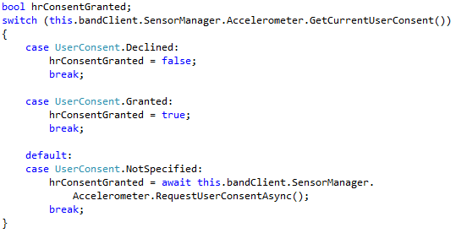

Storing the acceleration in the x,y and z direction into variables so we can use the results throughout the program.

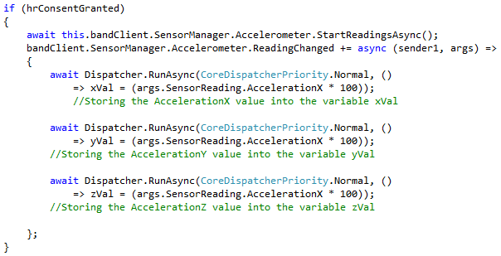

**Waves**

Using the different calculations we can calculate the different wave types e.g. Sine, Triangle, Square and Sawtooth. Using the band we are able to alter the frequency of any wave. Using the acceleration in the X direction (xVal) we can alter the frequency of the wave.



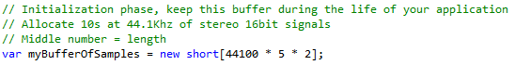



**Volume Slider**

While playing a wave file we are able to alter the volume using a slider.

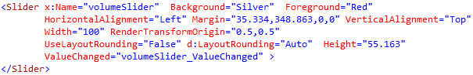

Giving the media element a volume, we can use this with the value of the slider divided by the maximum (100) to get a media volume between 0 and 1.



**Navigate between Pages**

Using a button we can navigate between pages.

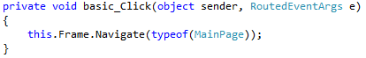

**SoundBoard:**

Adding buttons in sections of the display we are able to create a simple design SoundBoard.

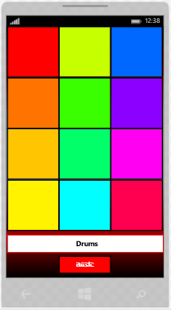



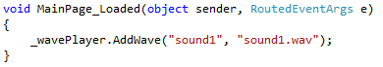

Using the WavePlayer file we are able to add alternate sounds ( variable name, file name).

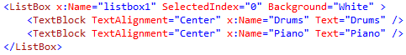

Adding listbox to the xaml file, it is possible to add alternate possibilities e.g. drums, piano. Using a simple if statement it is possible to choose the sounds you want to play. See code below.

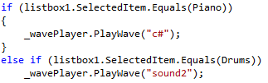

SharpDX is an open-source managed .NET wrapper of the DirectX API.